1. 7KN powercenter 3000 IOT gateway and data platform
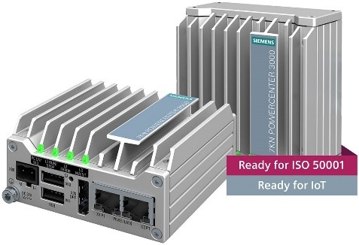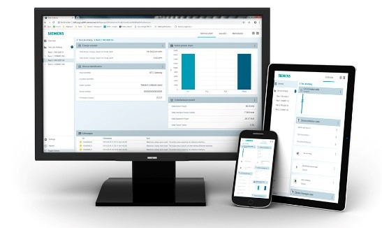

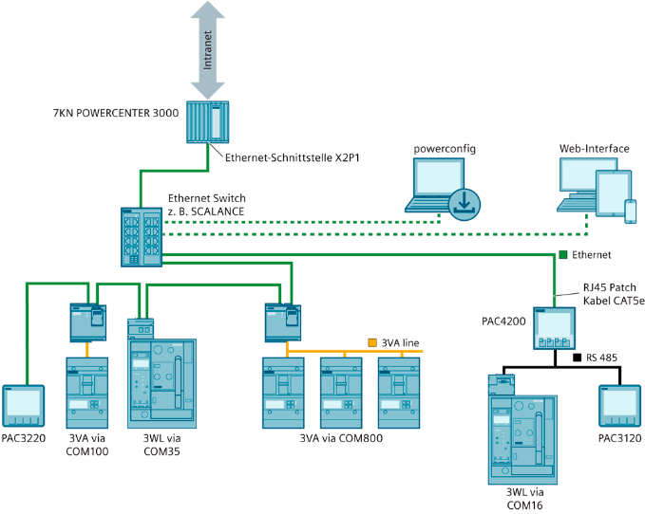

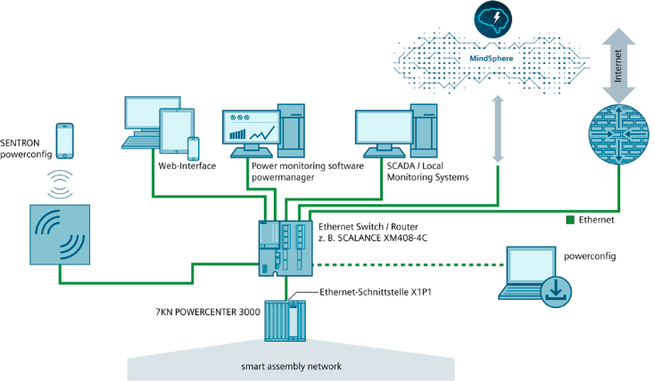
7KN powercenter 3000 IOT gateway and data platform

Brief description:
The IoT data platform is a system for the acquisition, storage, messaging, display and transmission of data from connected Siemens SENTRON measuring and protection devices or generic Modbus devices. Up to 32 devices can be connected to the system. Their values are read out, cached in the internal memory and displayed on the web server in different dashboards. 15-minute energy values can be stored for up to 14 months and exported from the device via an export function for further analysis. The values can also be forwarded to the Siemens proprietary cloud application SENTRON powermind (based on MindSphere) or to other cloud applications by means of MQTT protocol. The system offers a wide range of IT security setting options. The stored data form the basis for an energy management system (according to ISO 50001), an energy audit (according to DIN EN 16247-1) or for the calculation of energy performance indicators (according to ISO 50006). The data can be further processed with external tools, such as MS EXCEL, based on various export options.
Functions that can be called via the integrated web interface:
- Simple overview/introduction to energy monitoring and condition monitoring on site
- Easy networking of systems across different locations possible by connecting to a cloud application such as SENTRON powermind
- Project structure mapping and detailed views for each device (dashboard, measured variables, actions)
- Freely configurable dashboard
- Alarm and message view (freely definable messages, warnings and alarms can be displayed directly in a separate view)
- Status and condition display for devices (including RLT indicator for protection devices if protection device function is supported)
- Current measured values and history over time
- Graphical and numeric views
- User management
- Connection of up to 32 Modbus TCP devices (devices with other communication interfaces, e.g. Modbus RTU, can also be addressed by means of a gateway function)
- Easy integration of SENTRON measuring and protection devices (configuration instead of programming) directly via the web interface (network scan function)
- Export option (download or e-mail) for stored data
- e-mail notification possible for certain events
- Function scope can be expanded by means of firmware updates
- Multilingual web interface: 10 languages can be selected directly in the web interface
Technical specifications:
- Degree of protection IP20 (IP40 at the front)
- Power supply: 20.4 to 28.8 V
- DIN-rail or wall mounting
- Dimensions (WxHxD): 85 mm x 85 mm x 41 mm
Cybersecurity:
- BIOS hardening (secure boot sequence, deactivation of functions that are not required)
- Firmware (secure download process, signed firmware, not downgradable)
- Encrypted communication (secure MQTT)
- Security setting options (write protection, whitelist, firewall)
- User administration
- Physical separation between external and internal network
Connectivity:
Integrated, physically separate interfaces: 2 x Ethernet RJ45 (Modbus TCP, MQTT, HTTPS protocols)
Parameterization software:
Multilingual SENTRON powerconfig software tool for fast and easy commissioning and for diagnostics and service as a free download for PC and mobile

Siemens, 7KN Powercenter 3000
7KN1
Quantity: 1 Stck

